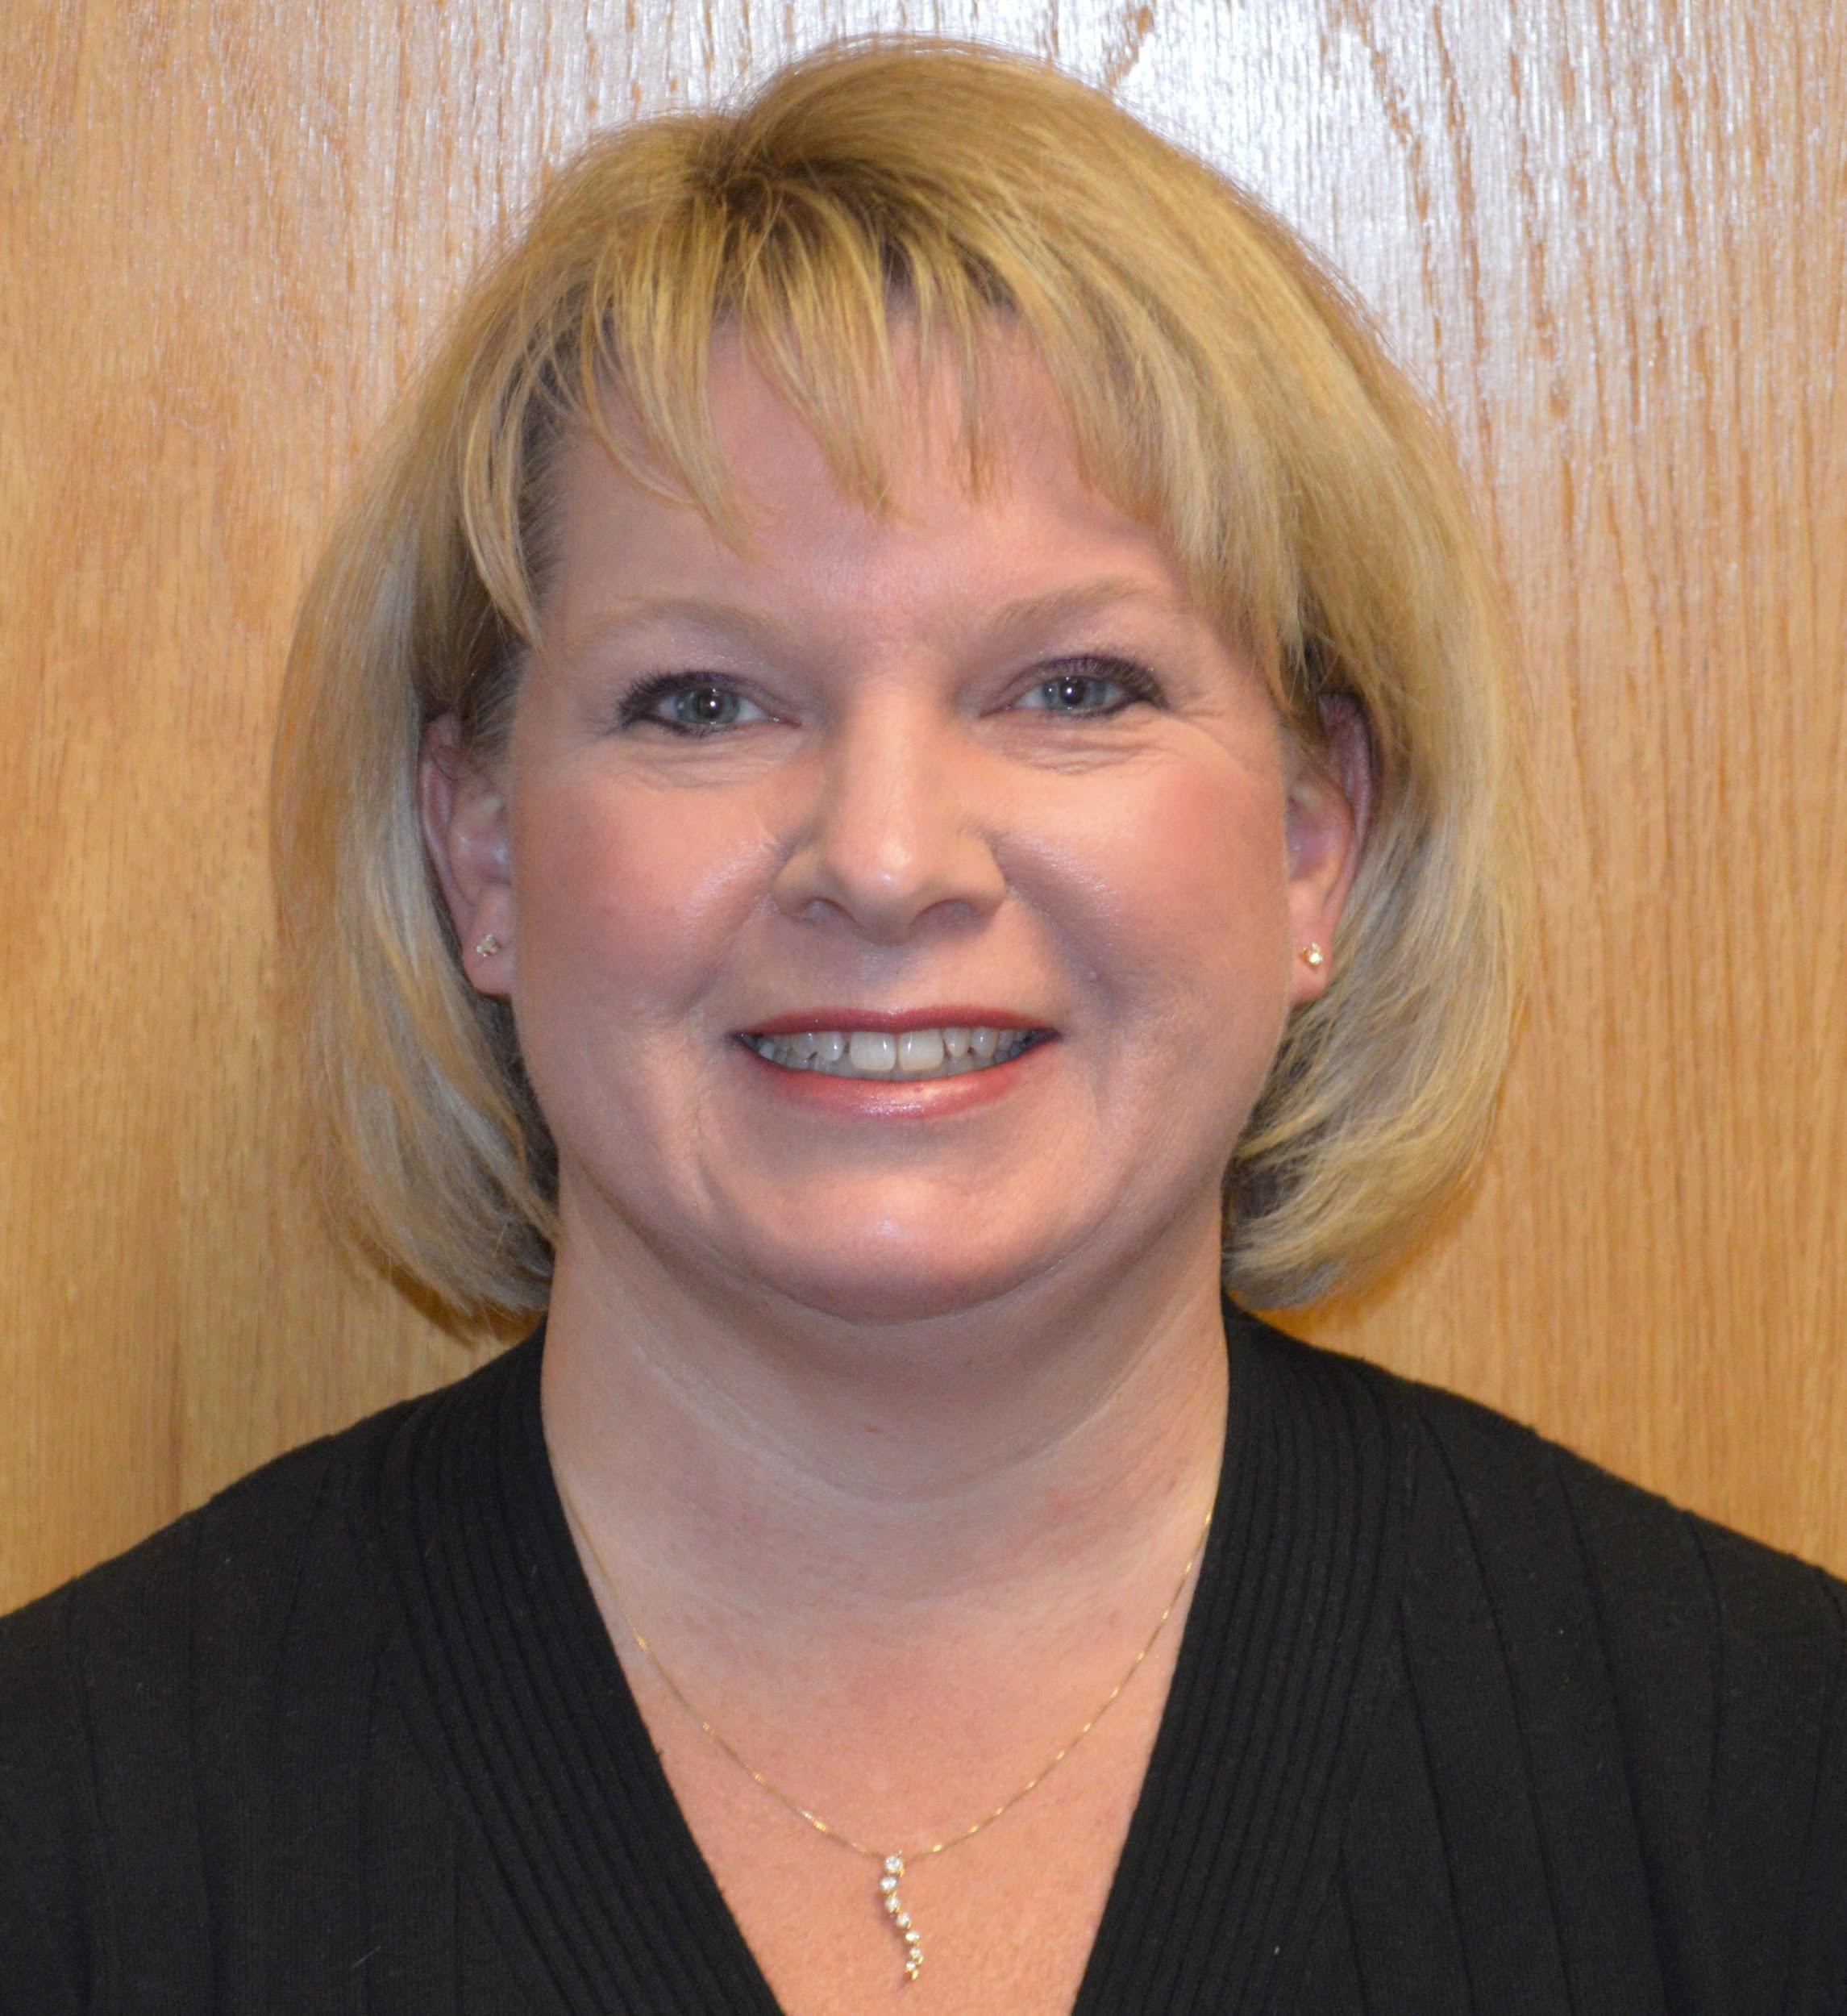
Amy Dolan Strano
Amy Dolan Strano is the President of the ACHIEVA Family Trust and was one of the original members of the Planning Committee which guided ACHIEVA in the creation of ACHIEVA Family Trust in 1998. She was also a long standing member of the ACHIEVA Family Trust Board of Trustees, having also served as the Board's Chairperson.
Prior to joining ACHIEVA Family Trust, Amy spent more than 10 years in the UPMC Corporate Legal Department, representing Western Psychiatric Institute & Clinic and Magee-Women’s Hospital as Associate Counsel. Amy also represented the Department of Human Services for Allegheny County as Assistant County Solicitor, a job she held before working at UPMC.
Amy is a cum laude graduate of Bethany College and the Duquesne University School of Law. She taught Mental Health Law at The University of Pittsburgh School of Law from 2005 through 2008 and is active in the Allegheny County Bar Association, as the past Chair of the Elder Law Committee, and past Chair of the Health Law Section. She is also a member of the Committee on Law and Disability. Amy is a member of the National Association of Elder Law Attorneys (NAELA) as well as the Pennsylvania Chapter (PAELA). She currently serves on the board of Vincentian’s Child Development Center.

